UNIT 10
LO 3 - WORKSHEET

Question Number 1:-

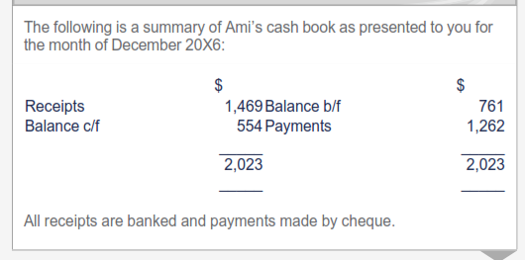
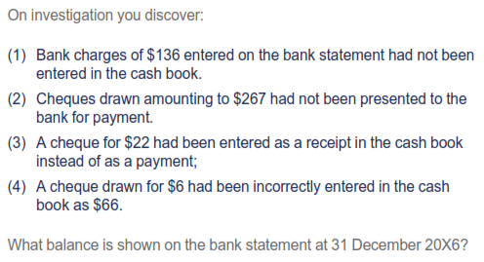

Question Number 2.
The drafts accounts for the year ended October 31, 2009 of Thomas P. Lee, garage proprietor the balance at bank according to the cash book was $894.68 in hand.
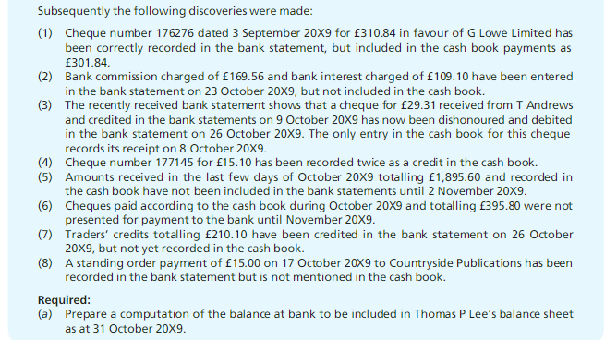

Sources:
Wood, F. and Sangster, A. (2005). Business Accounting Volume 1. Pearson Education UK.
ACCA Paper F3 Financial Accounting. (2018). Berkshire UK: Kaplan Publishing.

