LO 4
TERM PAPER ASSIGNMENT
Control Account Reconciliation
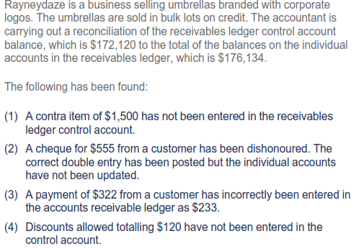
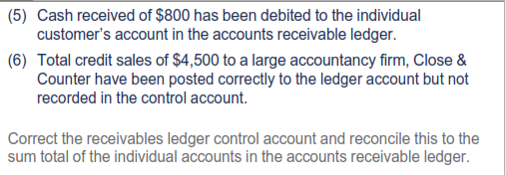

2. Suspense accounts
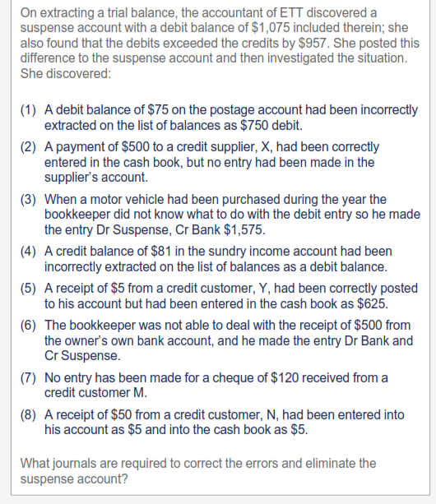

REFERENCES:
ACCA Paper F3 Financial Accounting (2008) Berkshire UK: Kaplan Publishing

