Unit 10
Term paper Assignment – Partnership
Bush, Home and Wilson share profits and losses in the ratios 4:1:3 respectively. Their trail balance as at April 30, 2004 was as follows:
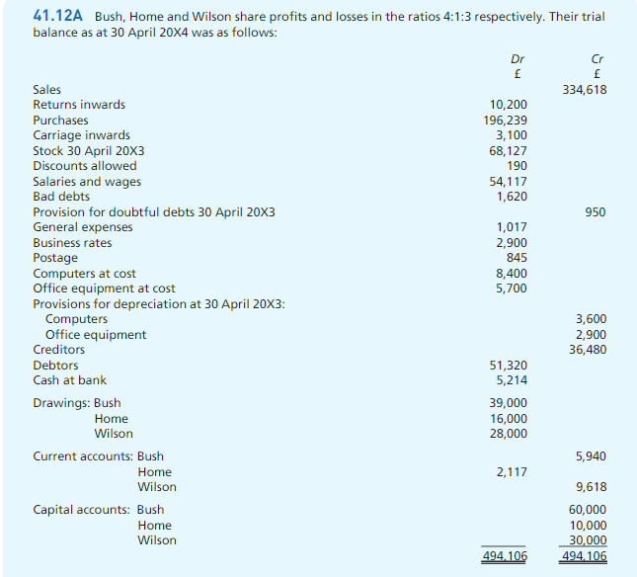
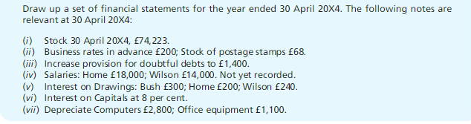

Company Accounts:
Below is the trail balance of Falta Ltd. As of April 30,2005:
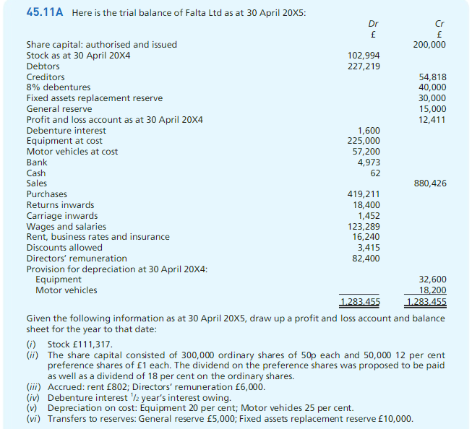

Sole Trader
The following trial balance has been extracted from the ledger of Mr. Yousef, a sole trader.
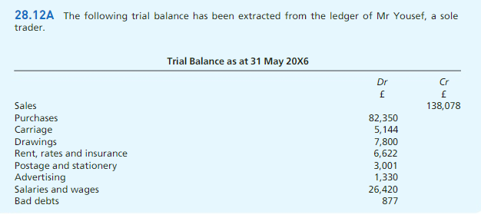
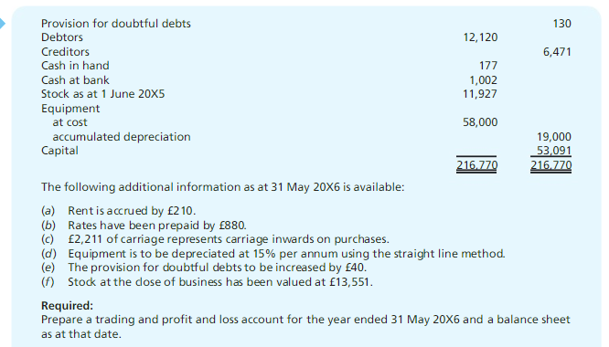

Source: Business Accounting Volume 1

