CASE STUDY – Role & Function of HR

Read the excerpt below and discuss:

Great people management makes the difference

Posted by Ariya Furkfon

If anybody asks whether human resource management is important, we believe no one will reply ‘no’ because machines definitely will not be able to function without people. But if anybody asks how it is important to the business, there are various different answers as each business has different economic factors such as capital, technology, machine, and knowhow.

However for the airline industry, Ariya Furkfon, Managing Consultant at Hay Group found that the different airlines can be compared easily regarding human resource management because of the similarity of machine between Boeing and Airbus, the same international aviation rules & regulations, and some similar operational standards for example. Therefore, in this dynamic competitive business, we are able to demonstrate the importance of HR easily. Ariya reveals the importance of HR in airline industry as follows.

Data from IATA shows that an effective airline is the airline that can develop effectiveness in 3 key productivity drivers; fuel productivity, aircraft productivity, and labor productivity; as shown in figure 1. In the past 40 years, it is shown that due to the limitation of improvement in engineering, fuel and aircraft productivity have less impact than improvement of labor productivity making differentiating between well and bad performers.
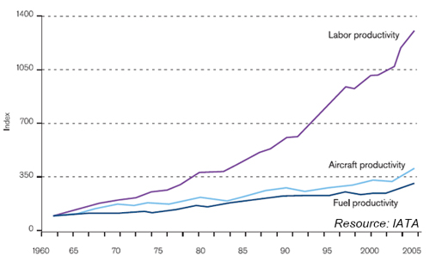
Figure 1 Capital effectiveness development
Furkfon, A. (2014). Great people management makes the difference. [Blog] HayGroup. Available at: http://blog.haygroup.com/great-people-management-makes-the-difference/ [Accessed 9 Jan. 2017].
DISCUSS:
How can the HR department of an Airline contribute to the Company’s ability to outperform their competitors?

